Report: Substring

1. Explain the problem and identify evaluation metrics for experiments
   1. We are given code that attempts to find substring by analyzing each character of a string one by one. This is horribly inefficient especially when we are looking at bigger text, so we need to implement some sort of multi-threading. Multithreading will allow us to compare multiple characters at once reducing the overall time by a good margin.
2. Explain your choice of threading libraries
   1. I chose pthreads as the threading library because it was used in example codes given to us and I have had some experience with it in previous classes.
3. Explain the design of the experiment and develop programs for evaluation
   1. First, I worked on the main function and implemented a way to open string.txt and then separating the strings into the main string and the substring. Then I created a thread array which has 4 cores attached to it. Each thread will try to find the substring by analyzing characters based its core number and every 4 characters after that. The totals will be kept local and will be added at the end.
4. Detail your collected experimental results
   1. Shakespeare, Romeo (1st image)
   2. Hamlet, Hamlet (2nd image)

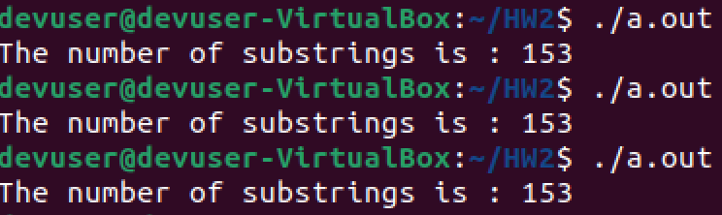

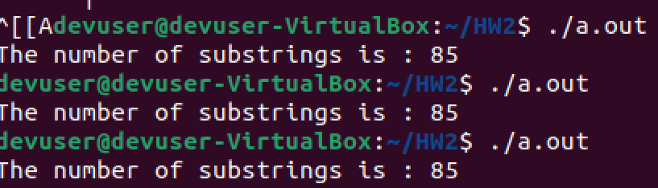

1. Using multithreading allowed me to save a lot of time running through the code especially on extremely long texts like Shakespeare. I saw time reductions reaching 90% and it is clear that multithreading is the better option for overall time.